|  |
| --- |
| Data Analysis of E-Commerce Data from Big Basket using linear regression |

**Date : 07-16-2023**

|  |  |
| --- | --- |
| **Project Start Date - End Date** | * Start Date – 07 -06 -2023 * End Date – 07 -16 2023 |
| **Objectives** | * General descriptive analyses * General exploratory analyses * To analyze revenue using the features in the dataset and predict near future revenue using linear regression machine learning model |
| **Milestones accomplished the week of Start Date - End Date:** | * Calculate accuracy metrics for performance evaluation of the model. * Conduct regression analysis to explore relationships between variables. * Detect and handle outliers in the dataset. * Predict future values using the developed data analysis model. |
|  |  |
|  |  |
|  |  |
|  |  |

# Contact Information

This project is performed for educational purpose of under the guidance of Siddhivinayak Sir

|  |  |
| --- | --- |
| **Project Manager**  Name: Siddhivinayak Phulwadkar  Mobile: 9028965955  Email: [siddhivinayakphulwadkar@gmail.com](mailto:siddhivinayakphulwadkar@gmail.com) | **Student Name**  Name: MARJIBA  Mobile: +91 8415946250  Email: marjibajamir9@gmail.com |

# Project Abstract

In this project, we aim to perform advanced data analysis on the shopping data obtained from the e-commerce platform Big Basket. Our main objective is to develop an accurate and efficient data analysis model that can provide valuable insights into customer behavior and other relevant aspects. The tasks to be accomplished include:

**Calculate Accuracy**: Develop a code to calculate the accuracy of the data analysis model. This accuracy metric will be used to evaluate the performance of the model in predicting customer behavior or any other relevant aspect.

**Regression Analysis:** Explore other variables within the dataset as independent variables and apply regression analysis.

**Outlier Detection**: Identify and remove outliers from the dataset.

**Prediction of Future Values:** Utilize the developed data analysis model to predict the next 10 values in the given dataset.

**Some General Descriptive Data:**

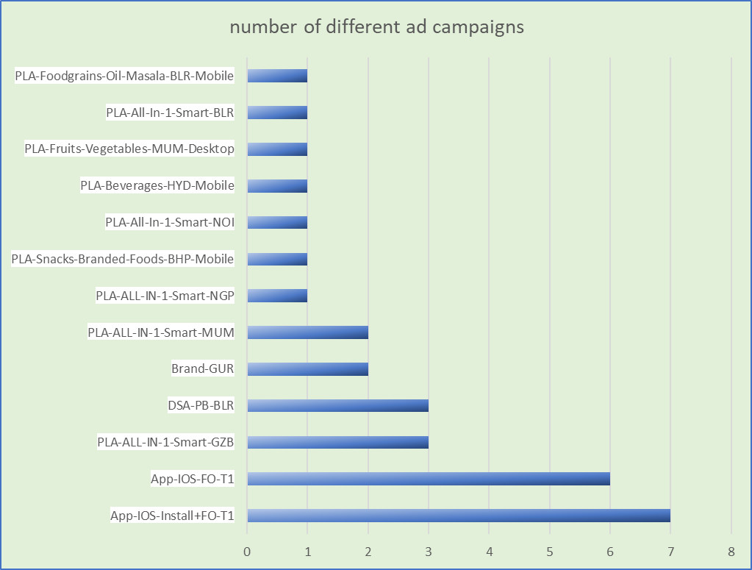

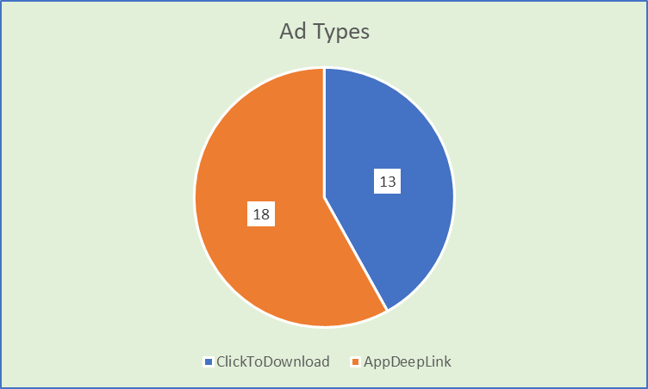

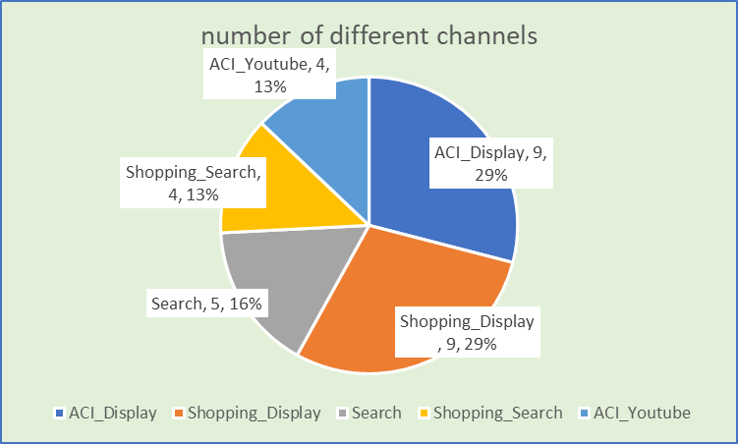

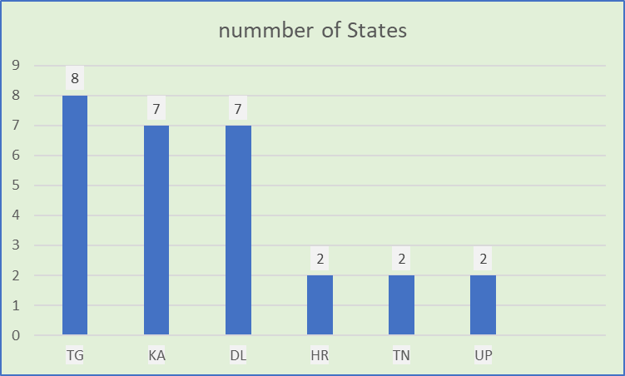

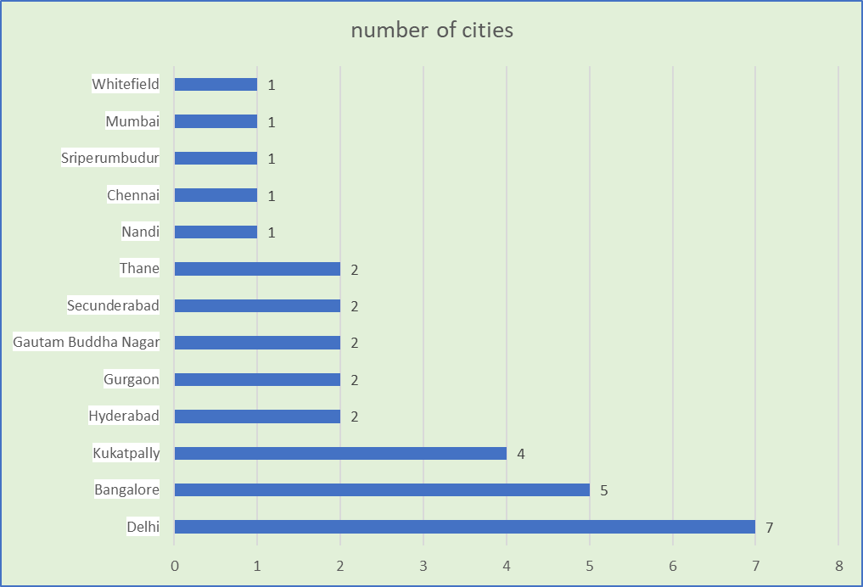

Python Code

import pandas as pd  
import numpy as np  
import matplotlib.pyplot as plt  
from sklearn.model_selection import train_test_split  
from sklearn.linear_model import LinearRegression  
from sklearn.metrics import r2_score

# save the path of csv file in a variable called path  
path="C:/Users/rooki/OneDrive/Desktop/9 july in app ios.csv"  
  
# Load the dataset into a pandas dataframe  
bbdata = pd.read_csv(path)  
  
# Print the first few rows of the dataframe to verify the data has been loaded correctly  
bbdata.head()

Attributed Touch Type Event Name \  
0 click placeorder   
1 click placeorder   
2 click placeorder   
3 click placeorder   
4 click placeorder   
  
 Event Value Event Revenue \  
0 {"af_content_type":"product","order id":"21135... 702.00   
1 {"af_content_type":"product","order id":"21134... 1595.00   
2 {"af_content_type":"product","order id":"21133... 713.51   
3 {"af_content_type":"product","order id":"21133... 1886.27   
4 {"af_content_type":"product","order id":"21132... 468.45   
  
 Event Revenue Currency Event Revenue USD Cost Model Cost Value \  
0 INR 9.320797 NaN NaN   
1 INR 21.184909 NaN NaN   
2 INR 9.476893 NaN NaN   
3 INR 25.048669 NaN NaN   
4 INR 6.220768 NaN NaN   
  
 Cost Currency Event Source ... Is Retargeting \  
0 NaN SDK ... False   
1 NaN SDK ... False   
2 NaN SDK ... False   
3 NaN SDK ... False   
4 NaN SDK ... False   
  
 Retargeting Conversion Type Is Primary Attribution Attribution Lookback \  
0 NaN True 30d   
1 NaN False 30d   
2 NaN True 30d   
3 NaN True 30d   
4 NaN True 30d   
  
 Reengagement Window Match Type \  
0 NaN srn   
1 NaN srn   
2 NaN srn   
3 NaN srn   
4 NaN srn   
  
 User Agent HTTP Referrer \  
0 bigbasket/6.2.2 CFNetwork/1240.0.4 Darwin/20.6.0 NaN   
1 bigbasket/6.2.2 CFNetwork/1197 Darwin/20.0.0 NaN   
2 bigbasket/6.2.2 CFNetwork/1209 Darwin/20.2.0 NaN   
3 bigbasket/6.2.2 CFNetwork/1209 Darwin/20.2.0 NaN   
4 bigbasket/6.2.2 CFNetwork/1240.0.4 Darwin/20.6.0 NaN   
  
 Original URL Store Product Page   
0 NaN NaN   
1 NaN NaN   
2 NaN NaN   
3 NaN NaN   
4 NaN NaN   
  
[5 rows x 56 columns]

bbdata.shape

(31, 56)

#### the dataset contains 31 rows and 56 columns (features) the first step is to filter out the irrelevent features and Pre-process the data

# we'll use the first 4 columns which include: Attributed touch type, Event Name, Event Value and Event Revenue  
data_1 = bbdata.iloc[:,:4]

data_1.head()

Attributed Touch Type Event Name \  
0 click placeorder   
1 click placeorder   
2 click placeorder   
3 click placeorder   
4 click placeorder   
  
 Event Value Event Revenue   
0 {"af_content_type":"product","order id":"21135... 702.00   
1 {"af_content_type":"product","order id":"21134... 1595.00   
2 {"af_content_type":"product","order id":"21133... 713.51   
3 {"af_content_type":"product","order id":"21133... 1886.27   
4 {"af_content_type":"product","order id":"21132... 468.45

data_1.describe()

Event Revenue  
count 31.000000  
mean 1115.810968  
std 1339.215906  
min 75.000000  
25% 389.000000  
50% 713.510000  
75% 1334.000000  
max 6990.000000

# although not obvious immediately, we can notice that the maximum revenue is 69900 where as the 75th percentile revenue is  
# only 1334, this indicates that entry number 22 (Event Revenue is an outlier)  
# the idea way to handle this would be to remove this since, 1 datapoint is roughly 3% of the whole dataset.

# Drop the row using drop function  
data_1 = data_1.drop(22)  
  
# Resetting the index  
data_1 = data_1.reset_index(drop=True)

data_1.head()

Attributed Touch Type Event Name \  
0 click placeorder   
1 click placeorder   
2 click placeorder   
3 click placeorder   
4 click placeorder   
  
 Event Value Event Revenue   
0 {"af_content_type":"product","order id":"21135... 702.00   
1 {"af_content_type":"product","order id":"21134... 1595.00   
2 {"af_content_type":"product","order id":"21133... 713.51   
3 {"af_content_type":"product","order id":"21133... 1886.27   
4 {"af_content_type":"product","order id":"21132... 468.45

data_1.describe()

Event Revenue  
count 30.000000  
mean 920.004667  
std 791.085620  
min 75.000000  
25% 381.500000  
50% 707.755000  
75% 1224.250000  
max 3530.000000

##### Let's convert the features into numerical values and see which features can help predict our dependent variable (Event Revenue)

# Mapping for "Attributed Touch Type"  
touch_type_mapping = {'click': 1} # Add more mappings as needed  
  
# Mapping for "Event Name"  
event_name_mapping = {'placeorder': 1} # Add more mappings as needed  
  
# Convert "Attributed Touch Type" column  
data_1['Attributed Touch Type'] = data_1['Attributed Touch Type'].map(touch_type_mapping)  
  
# Convert "Event Name" column  
data_1['Event Name'] = data_1['Event Name'].map(event_name_mapping)

data_1.head()

Attributed Touch Type Event Name \  
0 1 1   
1 1 1   
2 1 1   
3 1 1   
4 1 1   
  
 Event Value Event Revenue   
0 {"af_content_type":"product","order id":"21135... 702.00   
1 {"af_content_type":"product","order id":"21134... 1595.00   
2 {"af_content_type":"product","order id":"21133... 713.51   
3 {"af_content_type":"product","order id":"21133... 1886.27   
4 {"af_content_type":"product","order id":"21132... 468.45

#### Now that we have everything in numerical form, we can split the data into train - test uisng available library and then, build a linear Regression model and finally check our model's accuracy.

# convert the DataFrame to values  
X = data_1.iloc[:, 0:1].values  
y = data_1.iloc[:, -1].values

# Split the data into training and testing sets  
X_train, X_test, y_train, y_test = train_test_split(X, y, test_size=0.3, random_state=42)

X_train

array([[1],  
 [1],  
 [1],  
 [1],  
 [1],  
 [1],  
 [1],  
 [1],  
 [1],  
 [1],  
 [1],  
 [1],  
 [1],  
 [1],  
 [1],  
 [1],  
 [1],  
 [1],  
 [1],  
 [1],  
 [1]], dtype=int64)

X_test

array([[1],  
 [1],  
 [1],  
 [1],  
 [1],  
 [1],  
 [1],  
 [1],  
 [1]], dtype=int64)

y_train

array([ 702. , 468.45, 1154.52, 715.71, 693. , 663. , 1174. ,  
 1595. , 713.51, 407. , 1886.27, 3530. , 2565.59, 100. ,  
 896.6 , 1804.11, 1241. , 1124.95, 1549.91, 246.6 , 442.84])

y_test

array([ 75. , 920.42, 149. , 404. , 1427. , 125. , 223. ,  
 374. , 228.66])

# Train a linear regression model on the data  
model = LinearRegression()  
model.fit(X_train, y_train)

LinearRegression()

# Make predictions  
y_pred = model.predict(X_test)

y_pred

array([1127.33619048, 1127.33619048, 1127.33619048, 1127.33619048,  
 1127.33619048, 1127.33619048, 1127.33619048, 1127.33619048,  
 1127.33619048])

# Calculate the accuracy (R^2 score)  
accuracy = r2_score(y_test, y_pred)  
accuracy

-2.6544931229972804

# Plot the results  
plt.scatter(X_test, y_test, color='blue', label='Actual')  
plt.plot(X_test, y_pred, color='red', label='Predicted')  
plt.xlabel('Attributed Touch Type')  
plt.ylabel('Event Revenue')  
plt.title('Linear Regression - Attributed Touch Type vs Event Revenu')  
plt.legend()  
plt.show()

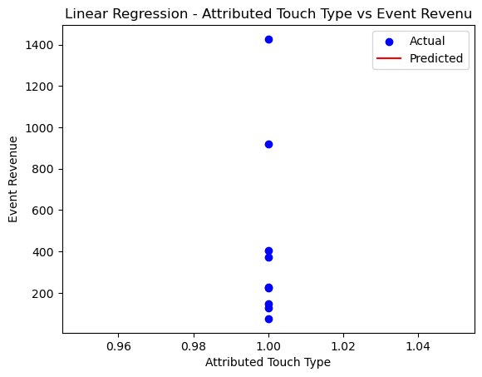

data_2=bbdata.iloc[:,3:14]

data_2.head()

Event Revenue Event Revenue Currency Event Revenue USD Cost Model \  
0 702.00 INR 9.320797 NaN   
1 1595.00 INR 21.184909 NaN   
2 713.51 INR 9.476893 NaN   
3 1886.27 INR 25.048669 NaN   
4 468.45 INR 6.220768 NaN   
  
 Cost Value Cost Currency Event Source Partner Media Source \  
0 NaN NaN SDK NaN googleadwords_int   
1 NaN NaN SDK NaN googleadwords_int   
2 NaN NaN SDK NaN googleadwords_int   
3 NaN NaN SDK NaN googleadwords_int   
4 NaN NaN SDK NaN googleadwords_int   
  
 Channel Campaign   
0 ACI_Display App-IOS-FO-T1   
1 Shopping_Display PLA-ALL-IN-1-Smart-NGP   
2 Search Brand-GUR   
3 Search Brand-GUR   
4 ACI_Display App-IOS-FO-T1

from sklearn.preprocessing import LabelEncoder

# Convert the "Channel" column to numerical format  
label_encoder = LabelEncoder()  
data_2['Channel'] = label_encoder.fit_transform(data_2['Channel'])  
data_2['Campaign'] = label_encoder.fit_transform(data_2['Campaign'])  
  
# Print the updated DataFrame  
data_2.head()

Event Revenue Event Revenue Currency Event Revenue USD Cost Model \  
0 702.00 INR 9.320797 NaN   
1 1595.00 INR 21.184909 NaN   
2 713.51 INR 9.476893 NaN   
3 1886.27 INR 25.048669 NaN   
4 468.45 INR 6.220768 NaN   
  
 Cost Value Cost Currency Event Source Partner Media Source \  
0 NaN NaN SDK NaN googleadwords_int   
1 NaN NaN SDK NaN googleadwords_int   
2 NaN NaN SDK NaN googleadwords_int   
3 NaN NaN SDK NaN googleadwords_int   
4 NaN NaN SDK NaN googleadwords_int   
  
 Channel Campaign   
0 0 0   
1 3 6   
2 2 2   
3 2 2   
4 0 0

# Drop the row using drop function  
data_2 = data_2.drop(22)  
data_2 = data_2.drop(21)  
  
# Resetting the index  
data_2 = data_2.reset_index(drop=True)

data_2.head()

Event Revenue Event Revenue Currency Event Revenue USD Cost Model \  
0 702.00 INR 9.320797 NaN   
1 1595.00 INR 21.184909 NaN   
2 713.51 INR 9.476893 NaN   
3 1886.27 INR 25.048669 NaN   
4 468.45 INR 6.220768 NaN   
  
 Cost Value Cost Currency Event Source Partner Media Source \  
0 NaN NaN SDK NaN googleadwords_int   
1 NaN NaN SDK NaN googleadwords_int   
2 NaN NaN SDK NaN googleadwords_int   
3 NaN NaN SDK NaN googleadwords_int   
4 NaN NaN SDK NaN googleadwords_int   
  
 Channel Campaign   
0 0 0   
1 3 6   
2 2 2   
3 2 2   
4 0 0

# convert the DataFrame to values  
X2 = data_2.iloc[:, 0].values.reshape(-1, 1)  
y2 = data_2.iloc[:, -2].values.reshape(-1, 1) # channel

X2

array([[ 702. ],  
 [1595. ],  
 [ 713.51],  
 [1886.27],  
 [ 468.45],  
 [ 715.71],  
 [ 442.84],  
 [1241. ],  
 [1427. ],  
 [ 125. ],  
 [1124.95],  
 [ 663. ],  
 [ 228.66],  
 [ 693. ],  
 [1549.91],  
 [ 920.42],  
 [1154.52],  
 [ 404. ],  
 [ 100. ],  
 [ 246.6 ],  
 [1804.11],  
 [1174. ],  
 [ 149. ],  
 [ 374. ],  
 [ 407. ],  
 [2565.59],  
 [ 75. ],  
 [ 223. ],  
 [ 896.6 ]])

y2

array([[0],  
 [3],  
 [2],  
 [2],  
 [0],  
 [3],  
 [0],  
 [4],  
 [3],  
 [1],  
 [1],  
 [0],  
 [0],  
 [0],  
 [3],  
 [3],  
 [4],  
 [3],  
 [2],  
 [4],  
 [3],  
 [0],  
 [2],  
 [3],  
 [3],  
 [1],  
 [1],  
 [2],  
 [0]])

# Split the data into training and testing sets  
X2_train, X2_test, y2_train, y2_test = train_test_split(X2, y2, test_size=0.4, random_state=42)

# Train a linear regression model on the data  
model2 = LinearRegression()  
model2.fit(X2_train, y2_train)

LinearRegression()

# Make predictions  
y2_pred = model2.predict(X2_test)

# Plot the results  
plt.scatter(X2_test, y2_test, color='blue', label='Actual')  
plt.plot(X2_test, y2_pred, color='red', label='Predicted')  
plt.xlabel('Event Revenue')  
plt.ylabel('channel')  
plt.title('Linear Regression - Channel vs Event Revenue')  
plt.legend()  
plt.show()

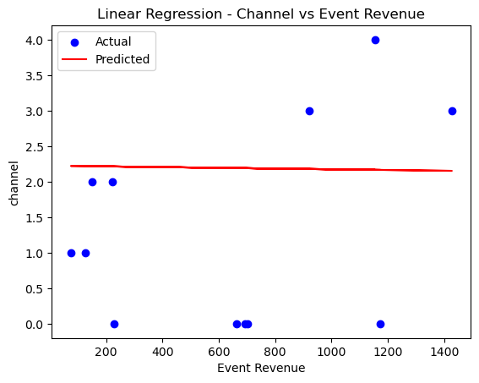

# Calculate the accuracy (R^2 score)  
accuracy2 = r2_score(y2_test, y2_pred)  
accuracy2

-0.40395883048994174

# convert the DataFrame to values  
y3 = data_2.iloc[:, 0].values.reshape(-1, 1)  
X3 = data_2.iloc[:, -1].values.reshape(-1, 1) # channel

X3

array([[ 0],  
 [ 6],  
 [ 2],  
 [ 2],  
 [ 0],  
 [ 8],  
 [ 0],  
 [13],  
 [ 9],  
 [ 1],  
 [ 1],  
 [ 1],  
 [ 1],  
 [ 1],  
 [ 5],  
 [ 5],  
 [10],  
 [ 4],  
 [ 3],  
 [12],  
 [ 7],  
 [ 0],  
 [ 3],  
 [ 4],  
 [ 4],  
 [ 1],  
 [ 1],  
 [ 3],  
 [ 0]])

y3

array([[ 702. ],  
 [1595. ],  
 [ 713.51],  
 [1886.27],  
 [ 468.45],  
 [ 715.71],  
 [ 442.84],  
 [1241. ],  
 [1427. ],  
 [ 125. ],  
 [1124.95],  
 [ 663. ],  
 [ 228.66],  
 [ 693. ],  
 [1549.91],  
 [ 920.42],  
 [1154.52],  
 [ 404. ],  
 [ 100. ],  
 [ 246.6 ],  
 [1804.11],  
 [1174. ],  
 [ 149. ],  
 [ 374. ],  
 [ 407. ],  
 [2565.59],  
 [ 75. ],  
 [ 223. ],  
 [ 896.6 ]])

# Split the data into training and testing sets  
X3_train, X3_test, y3_train, y3_test = train_test_split(X3, y3, test_size=0.3, random_state=42)

# Train a linear regression model on the data  
model3 = LinearRegression()  
model3.fit(X3_train, y3_train)

LinearRegression()

# Make predictions  
y3_pred = model3.predict(X3_test)

y3_pred

array([[939.3717494 ],  
 [948.40728016],  
 [936.79016918],  
 [939.3717494 ],  
 [947.11649005],  
 [936.79016918],  
 [935.49937907],  
 [935.49937907],  
 [936.79016918]])

# Plot the results  
plt.scatter(X3_test, y3_test, color='blue', label='Actual')  
plt.plot(X3_test, y3_pred, color='red', label='Predicted')  
plt.xlabel('campaign')  
plt.ylabel('Event Revenue')  
plt.title('Linear Regression - Campaign vs Event Revenue')  
plt.legend()  
plt.show()

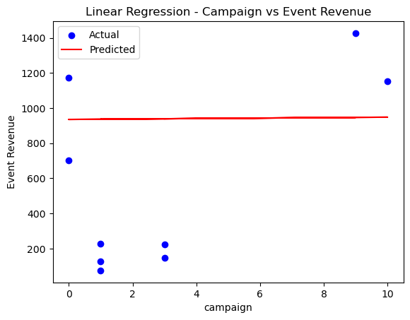

# Calculate the accuracy (R^2 score)  
accuracy3 = r2_score(y3_test, y3_pred)  
accuracy3

-0.48036726397303164

# try for next 10 values   
# Generate an array of 10 random numbers between 0 and 13  
campaign_array = np.random.randint(0, 14, size=10).reshape(-1, 1)

campaign_array

array([[ 9],  
 [ 1],  
 [ 6],  
 [ 7],  
 [ 6],  
 [ 5],  
 [ 8],  
 [ 7],  
 [10],  
 [12]])

campaign_predictions = model3.predict(campaign_array)  
# Make predictions  
y3_pred = model3.predict(X3_test)

campaign_predictions

array([[947.11649005],  
 [936.79016918],  
 [943.24411972],  
 [944.53490983],  
 [943.24411972],  
 [941.95332962],  
 [945.82569994],  
 [944.53490983],  
 [948.40728016],  
 [950.98886038]])

# Plot the results  
# plt.scatter(X3_test, y3_test, color='blue', label='Actual')  
plt.plot(campaign_array, campaign_predictions, color='red', label='Predicted')  
plt.xlabel('campaign')  
plt.ylabel('Event Revenue')  
plt.title('Linear Regression - Campaign vs Event Revenue')  
plt.legend()  
plt.show()

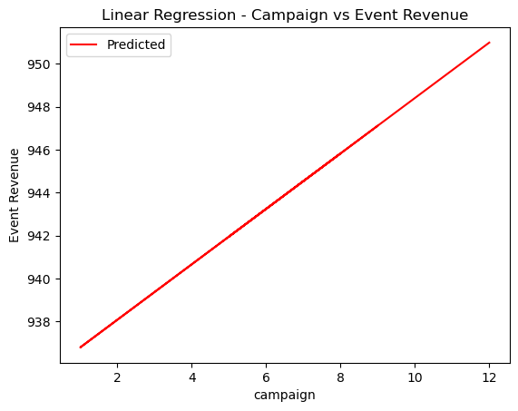

## predicted revenue for next 10 campaigns --   
campaign_predictions

array([[947.11649005],  
 [936.79016918],  
 [943.24411972],  
 [944.53490983],  
 [943.24411972],  
 [941.95332962],  
 [945.82569994],  
 [944.53490983],  
 [948.40728016],  
 [950.98886038]])

**Summary and Insights**

**Geographical User Distribution:** Telangana state leads with the highest number of interaction at 8, closely followed by Karnataka and Delhi, each with 7 users. Delhi city stands out with 7 interactions, making it the city with the highest interaction count. Bangalore and Kukatpally rank second and third with 5 and 4 interactions, respectively.

**Ad Performance Analysis:** The two primary ad types, "Click to Download" and "App Deep Link," have been analyzed for their performance. "Click to Download" ads constitute 58% of the ad types, while "App Deep Link" accounts for the remaining 42%. This information can assist in optimizing ad campaigns to target specific user preferences.

**Popular Channels for User Interaction:** The data highlights "Shopping Display" and "ACI Display" as the most popular channels for user engagement. Leveraging these channels can help improve customer interactivity and boost overall revenue.

**Revenue Prediction Models**: Linear regression models have been developed to predict event revenue based on channel and campaign data. The model accuracy, measured by the R2_SCORE metric, indicates negative values for both channel and campaign-based predictions.

This suggests that the current models may not be the best fit for revenue prediction, and further refinement may be necessary.

**Campaign-Based Revenue Prediction:** Using the campaign-based model to predict the next 10 revenues for randomly selected campaigns shows a linear regression line ranging approximately from 938 to 950 in revenue.

This prediction range can aid in setting revenue expectations and refining future marketing strategies.